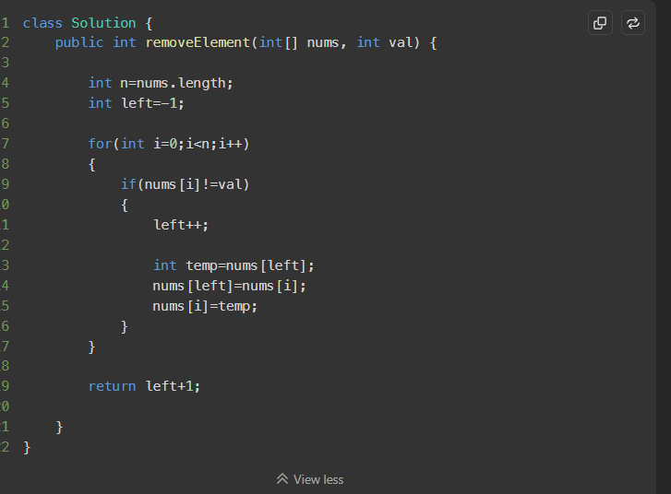

Link :
https://leetcode.com/problems/remove-element/submissions/1950169827

